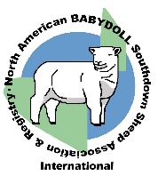 NABSSAR Babydoll Southdown Point Record Form 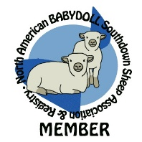

I, ________________________________, have exhibited the Babydoll Southdown E__/R__), full scrapie tag #_______________,
NABSSAR Registry #__________. The Babydoll placed _______________in a class of (total head in class) __________.
He/she was shown in the (open or junior) _______________division
of the following livestock show:______________________________________________________on date________________
This placing is verified by the superintendent of the above listed show.

_________________________________________ _______________________________
Superintendent’s name (please print) Superintendent telephone number

_________________________________________
Superintendent’s signature

Committee Use Only
I designate this show for double points (only one double points show per sheep).
Yes_____No_____

__________________________________________
Signature/Title and Approval
**ONLY NABSSAR registered sheep, entered using their NABSSAR registration number, qualify for points.
Make as many copies of this form as you need. A separate form is needed for each sheep.
All blanks must be completed prior to mailing to the NABSSAR or the form will be invalid.
The completed form must be postmarked within fourteen (14) days of the date of the show or is invalid.

Mail to: NABSSAR Show Committee, c/o Housend, 22205 Mahogany Rd, Kaplan, LA 70548
NABSSAR 03/2024

